100
Epoch 100/100
188/188 [==============================] - 58s 309ms/step - loss: 1.3918 - accuracy: 0.6165 - val_loss: 1.6872 - val_accuracy: 0.5079
9/9 [==============================] - 6s 398ms/step
there were 321 in 630 tests for an accuracy of 49.05
Classification Report:
----------------------
precision recall f1-score support

calling 0.2500 0.0238 0.0435 42
clapping 0.4857 0.4048 0.4416 42
cycling 0.7455 0.9762 0.8454 42
dancing 0.5714 0.5714 0.5714 42
drinking 0.7297 0.6429 0.6835 42
eating 0.8095 0.8095 0.8095 42
fighting 0.7895 0.7143 0.7500 42
hugging 0.3478 0.3810 0.3636 42
laughing 0.4444 0.4762 0.4598 42
listening_to_music 0.2500 0.0952 0.1379 42
running 0.6341 0.6190 0.6265 42
sitting 0.5652 0.3095 0.4000 42
sleeping 0.2264 0.2857 0.2526 42
texting 0.3696 0.4048 0.3864 42
using_laptop 0.2523 0.6429 0.3624 42

accuracy 0.4905 630
macro avg 0.4981 0.4905 0.4756 630
weighted avg 0.4981 0.4905 0.4756 630

model was saved as ./activities_49.04.h5

250
Epoch 250/250
188/188 [==============================] - 59s 313ms/step - loss: 0.8174 - accuracy: 0.7930 - val_loss: 1.7267 - val_accuracy: 0.5317
9/9 [==============================] - 5s 401ms/step
there were 300 in 630 tests for an accuracy of 52.38
Classification Report:
----------------------
precision recall f1-score support

calling 0.2826 0.3095 0.2955 42
clapping 0.7333 0.5238 0.6111 42
cycling 0.6735 0.7857 0.7253 42
dancing 0.6458 0.7381 0.6889 42
drinking 0.6970 0.5476 0.6133 42
eating 0.7321 0.9762 0.8367 42
fighting 0.6957 0.3810 0.4923 42
hugging 0.4468 0.5000 0.4719 42
laughing 0.4571 0.3810 0.4156 42
listening_to_music 0.2973 0.2619 0.2785 42
running 0.5952 0.5952 0.5952 42
sitting 0.4000 0.3333 0.3636 42
sleeping 0.4737 0.4286 0.4500 42
texting 0.4340 0.5476 0.4842 42
using_laptop 0.3966 0.5476 0.4600 42

accuracy 0.5238 630
macro avg 0.5307 0.5238 0.5188 630
weighted avg 0.5307 0.5238 0.5188 630

model was saved as ./activities_52.38.h5

500
Epoch 500/500
188/188 [==============================] - 58s 307ms/step - loss: 0.4827 - accuracy: 0.9182 - val_loss: 1.9322 - val_accuracy: 0.5762
9/9 [==============================] - 5s 392ms/step
there were 247 in 630 tests for an accuracy of 60.79
Classification Report:
----------------------
precision recall f1-score support

calling 0.4848 0.3810 0.4267 42
clapping 0.7857 0.5238 0.6286 42
cycling 0.9111 0.9762 0.9425 42
dancing 0.7674 0.7857 0.7765 42
drinking 0.3333 0.4048 0.3656 42
eating 0.8222 0.8810 0.8506 42
fighting 0.6829 0.6667 0.6747 42
hugging 0.6200 0.7381 0.6739 42
laughing 0.6129 0.4524 0.5205 42
listening_to_music 0.3509 0.4762 0.4040 42
running 0.8065 0.5952 0.6849 42
sitting 0.5510 0.6429 0.5934 42
sleeping 0.7568 0.6667 0.7089 42
texting 0.2667 0.2857 0.2759 42
using_laptop 0.6136 0.6429 0.6279 42

accuracy 0.6079 630
macro avg 0.6244 0.6079 0.6103 630
weighted avg 0.6244 0.6079 0.6103 630

model was saved as ./activities_60.79.h5

1000
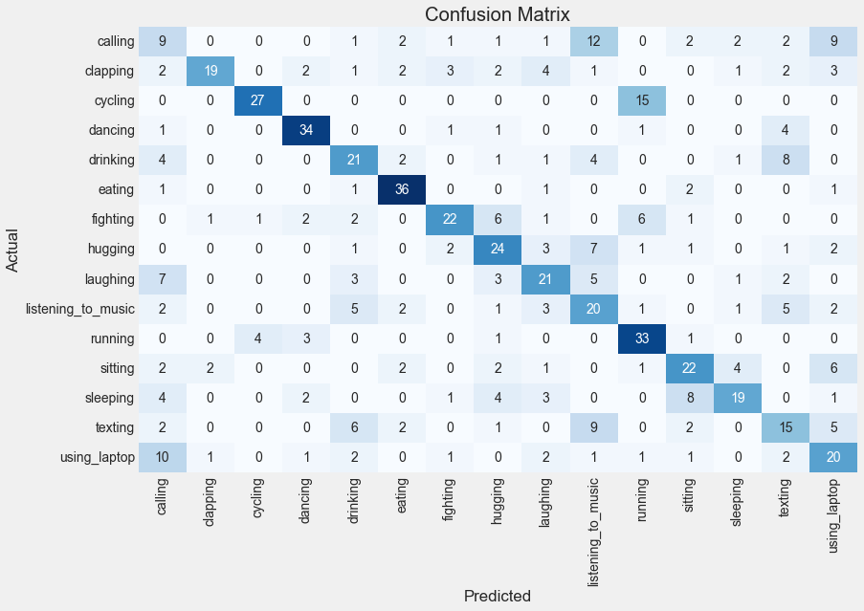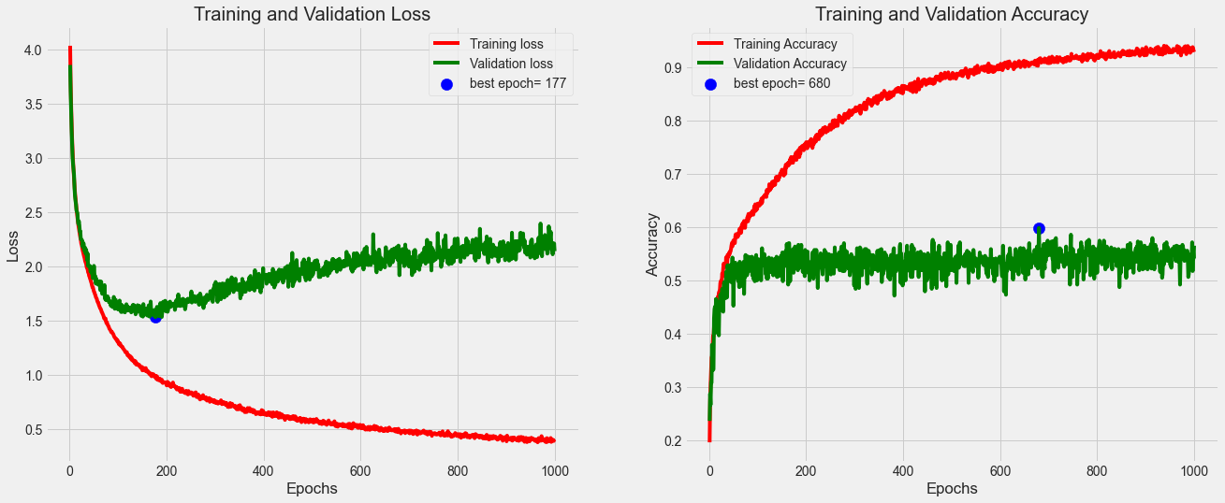
Epoch 1000/1000
188/188 [==============================] - 59s 310ms/step - loss: 0.4103 - accuracy: 0.9282 - val_loss: 2.1430 - val_accuracy: 0.5651
9/9 [==============================] - 6s 481ms/step
there were 288 in 630 tests for an accuracy of 54.29
Classification Report:
----------------------
precision recall f1-score support

calling 0.2045 0.2143 0.2093 42
clapping 0.8261 0.4524 0.5846 42
cycling 0.8438 0.6429 0.7297 42
dancing 0.7727 0.8095 0.7907 42
drinking 0.4884 0.5000 0.4941 42
eating 0.7500 0.8571 0.8000 42
fighting 0.7097 0.5238 0.6027 42
hugging 0.5106 0.5714 0.5393 42
laughing 0.5122 0.5000 0.5060 42
listening_to_music 0.3390 0.4762 0.3960 42
running 0.5593 0.7857 0.6535 42
sitting 0.5500 0.5238 0.5366 42
sleeping 0.6552 0.4524 0.5352 42
texting 0.3659 0.3571 0.3614 42
using_laptop 0.4082 0.4762 0.4396 42

accuracy 0.5429 630
macro avg 0.5664 0.5429 0.5453 630
weighted avg 0.5664 0.5429 0.5453 630

model was saved as ./activities_54.28.h5

